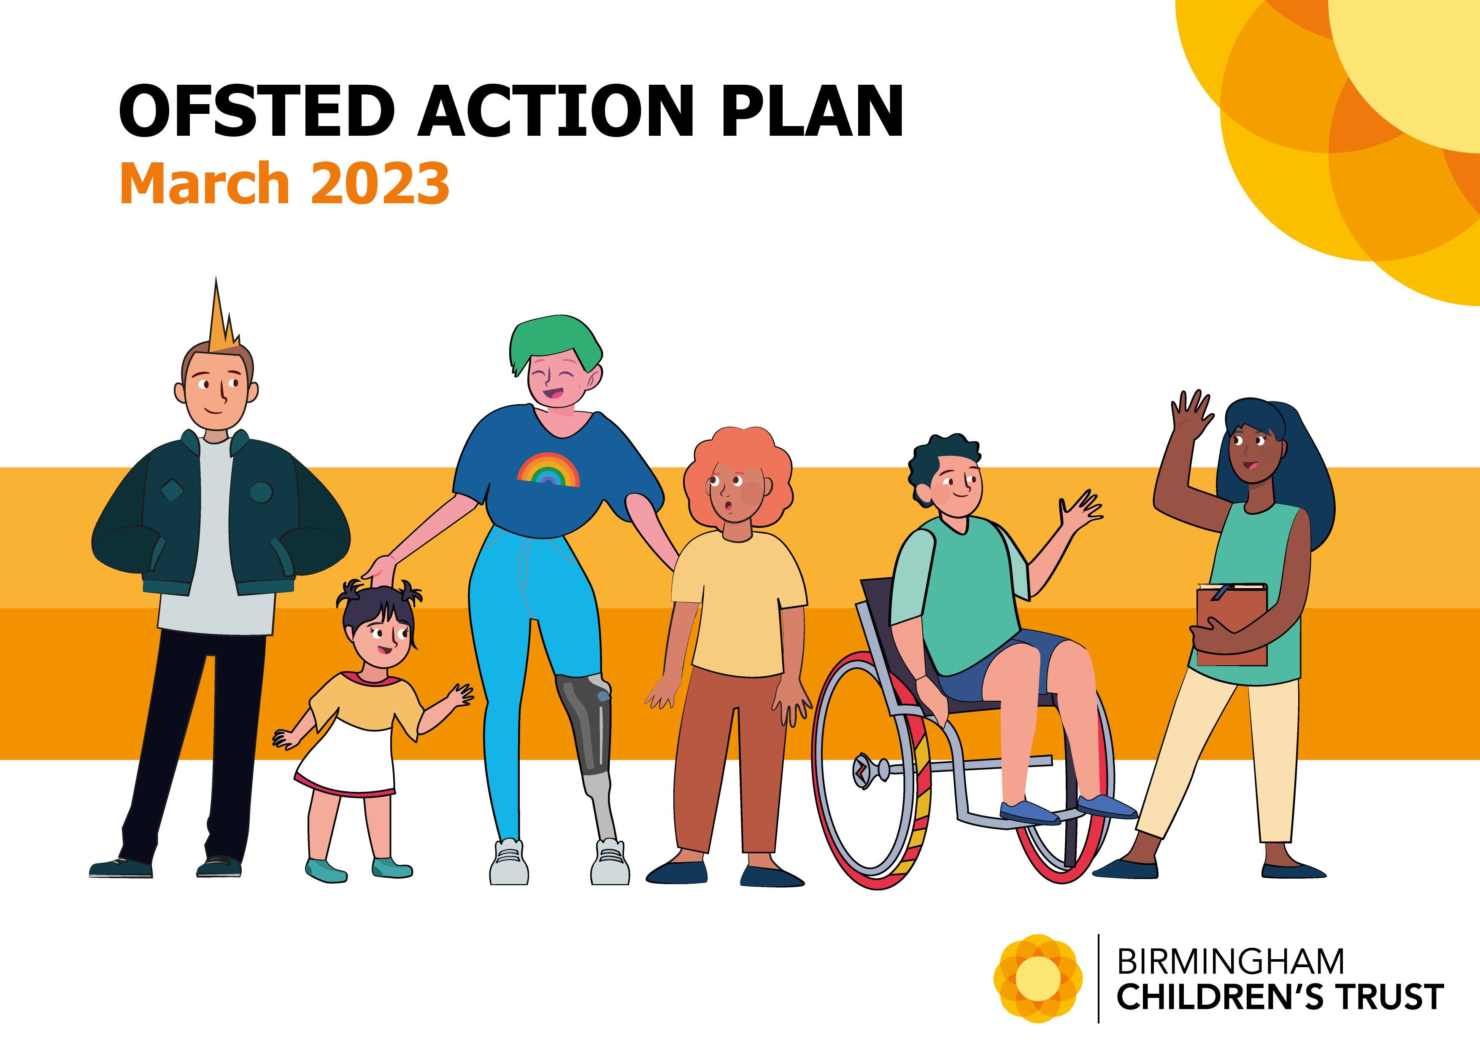
RAG status Key:
GREEN On Target for delivery
AMBER Delays / Issues but delivery on course
RED Major Issues preventing delivery
BLUE Complete

Actions starred* are carried forward from the previous plan with amended timescales

Ofsted Findings / Additional improvements identified through the process of inspection | Action | Lead | Time-scale | Update | Status
What needs to improve
The effectiveness of the response to domestic abuse.  The local authority and the trust have sought to develop the partnership response to the impact of domestic abuse on children and families. However, this remains under-resourced to respond effectively to the increasing level of demand. Despite investment in several additional services and dedicated management oversight, the absence of important partner agencies in the initial triaging process and the absence of perpetrator programmes for high-risk offenders are known concerns for the trust. They are continuing to escalate their concerns about the impact of this gap in provision on the safeguarding of children. | 1. Review and update the Partnership DA Strategy ensuring that the delivery of perpetrator interventions is included, and that the strategy takes account of the learning from the inspection  2. Pursue funding streams via the OPCC/VRP/BCC/partners to facilitate effective commissioning of a perpetrator interventions for high-risk offenders  3. Review the effectiveness of the DA Partnership Strategic Board in collaboration with BCC and BCSP  4. Explore options to pilot the 'case management' bid submitted to the OPCC  5. Maximise any opportunities that the DDP (Diversion Delivery Plan) presents  6. Finalise the DA Plan for the Trust (governance through the Trust DA Steering Group)  7. Release capacity/expertise already within the Trust to deliver DA programmes  8. Release capacity/expertise already within the Trust or explore commissioning to deliver support to children affected by domestic abuse | GT | Mar-24 | Up-date mid May 23: Meeting arranged with Deputy PCC to discuss gaps in the commissioning of perpetrator programmes for high-risk offenders
Earlier pre-birth assessments to support early permanence planning, and timely action to progress permanence plans for children in stable placements through changes to legal status.  Senior management oversight and arrangements to track progress of children’s early permanence are not sufficiently effective. Legal oversight of some children escalated into the pre-proceedings stage of the PLO is not sought early enough to prevent drift and delay. Equally, too many children experience delay in the discharge of orders when successfully placed with their parents. During this inspection, leaders have acknowledged these issues and are making organisational and strategic changes aimed at ensuring greater focus and improved outcomes for these children.  For unborn children who are at high risk of coming into care, planning for permanence does not routinely start at the earliest opportunity. Pre-birth assessments are of good quality but are not always commenced in a timely way, leading to delay in securing the right legal framework to protect children. Some babies are placed in foster care rather than being matched with early permanence placements. This means that some babies are not always provided with stability and security at the earliest opportunity. | 1. Develop a pathway for pre-birth assessments that reduces initial handover points (referral straight to pre-birth assessment), ensures effective checks/balances are in place through the assessment and sets out clear timescales for when legal advice is to be sought  2. Create additional dedicated resource/teams and bring under one line management structure to improve consistency of approach  3. Improve the use of legal tracking data through the Citywide PLO meeting to track progress  4. Make sure that IRO and CP Chair HoS are fully engaged in the strategic review of our approach  5. Use Ofsted findings to reinforce with IROS and CP Chairs their role and function to quality assure progression of children's plans and to use dispute resolution processes to effectively hold services to account  6. Fully utilise the learning and good practice guidance from the regional Midland Together Collaboration Early Permanence Project to inform our planning and approach | LH / JoR / GT / LJ | Jul-23 | Update mid April 23: Two additional pre-birth teams have been created. All three teams have been brought under the line management of one HoS. Pathway in development. Webinar planned for 2 May 23 providing an overview of our refreshed pre-proceedings guidance and templates which are being launched at the end of April 2023 and will be available in Tri. X Practice Guidance. The new practice approaches follow from extensive work with national and regional projects and reflect current national best practice and guidance.
Earlier engagement of personal advisers for children leaving care.  For most young people, PAs are not allocated soon enough, until close to their 18th birthday. Young people do not have access to the specialist expertise of the PA early enough to support early independence preparation. Once allocated to PAs, young people receive support to develop their independence skills. | 1. Continue ongoing recruitment campaigns  2. Ensure IROs are fully engaged through the review process to make sure that children that will benefit from earlier allocation of a PA receive one and use the DRP effectively if there is unmet need  3. Practice Academy to work with the service to think of creative ways to increase PA capacity | DM / GT / AxB | Jun-23 | Update mid-April 23: the Trust Exec has agreed funding for additional posts. Some posts have been recruited to but been submerged responding to increased UASC demand. Recruitment campaign is ongoing, but we are struggling to recruit suitable experienced/qualified staff. In the interim, PAs are allocated according to need.
Consistency of written plans.  The quality of child protection and child in need plans is inconsistent. When they are stronger, written plans consider children’s needs well and include their wishes and feelings. However, the inconsistent recording of the plans makes it difficult to understand how progress is monitored, as actions are not always timebound. Families would find it difficult to follow some plans without support. Safety planning is routinely considered but is inconsistently recorded and is sometimes ambiguous, and therefore difficult for families to understand. | 1. Review and amend current plan forms within Eclipse so that they are more family friendly  2. Strengthen our planning practice standard to include expectations for recording safety planning and the frequency at which safety plans should be reviewed  3. Re-circulate and reinforce our practice standards for effective planning with HoS and TMs to share with their teams  4. TMs to benchmark standards for SMART planning through practice forums and team meetings  5. Re-circulate and reinforce SMART family friendly actions in child protection plans with CP Chairs | GT / LH / AxB | Dec-23
Early Help and Protection
CASS/MASH initial decisions.  The quality of information from education does not always contribute effectively to decision-making in CASS. | 1. Increase education resource in MASH to include EmpowerU - table for discussion with CASS/MASH Partnership | MW  RB |  | Update mid-April 23: MW met with RB 18 April to initiate the conversation about requirements. Initial agreement = uplift of two posts. Further discussions to be had to clarify timescales for implementation
Strategy discussions.  An education representative or sufficient information from schools is not routinely available, resulting in decisions being made without full information. | 1. Increase education resource in MASH - table for discussion with CASS/MASH Partnership | MW  RB |  | Update mid-April 23: MW met with RB 18 April to initiate the conversation about requirements. Initial agreement = uplift of two posts. Further discussions to be had to clarify timescales for implementation
Single agency triage of low-level domestic abuse referrals.  Police make decisions on next steps without full consideration of partners’ information. This means that the trust cannot be assured that the needs and risks for children experiencing domestic abuse are fully understood. | 1. Quarterly audit of children screened by police as a single agency not referred to CASS to provide assurance on the quality and consistency of threshold decisions by police  2. Consider and review DA triage arrangements in the context of any changes to the MARAC delivery model | MW | First audit April 2023 | Update mid-April 23: First multi-agency audit completed mid-April, which provides assurance that single agency police threshold decisions are appropriate. Children are receiving a proportionate and appropriate response. Next audit planned for July and quarterly thereafter as BAU (business as usual).  DA triage arrangements reviewed in line with any changes to MARAC arrangements included as BAU.
Management oversight of long-term neglect.  For a small number of children suffering long-term neglect, social work visits and management oversight are less impactful, and children remain in neglectful situations for too long. | 1. Review and update the work programme for delivery of the Neglect Strategy and make sure that this addresses the learning identified in the inspection and prioritises effectively  2. Continue to roll out GCP2 training across the Trust and with partners  3. Use Ofsted findings to reinforce with Team Managers their role and function to quality assure progression of children's plans through effective supervision  4. Use Ofsted findings to reinforce with CP Chairs their role and function to quality assure progression of children's plans and to use dispute resolution processes to effectively hold services to account  5. Include neglect in the multi-agency and Trust thematic audit programme | GT / AxB | Dec-23 | Update mid-April 23: Multi-agency roll out of GCP2 is already in train. Neglect Strategy is in place but has not yet had time to embed and demonstrate impact. Neglect remains a priority in the BSCP Development Plan.
Pre-Proceedings.  The quality of practice and management oversight for progressing children through the pre-proceedings stage of the Public Law Outline (PLO) has improved since the last inspection. However, some children experience drift and delay in how quickly their plans are progressed, and actions often remain outstanding for too long.  The language used in letters to parents makes it difficult for parents to understand what needs to be done to prevent care proceedings. | 1. Embed the monthly Citywide PLO Meeting to provide consistent senior leader oversight of the effectiveness of pre-proceedings  2. Re-instate the monthly AD Safeguarding/AD CiC meeting with CPOs to ensure consistency of approach and quality of management/performance information presented to the Citywide PLO Meeting  3. Use Ofsted findings to reinforce with IROS and CP Chairs their role and function to quality assure progression of children's plans and to use dispute resolution processes to effectively hold services to account  4. Implement the new suite of PLO/Pre-proceedings templates and practice standards, which includes a new letter to parents | LH / JoR | Jun-23 | Update mid-April 23: Monthly Safeguarding AD/CiC AD meeting with CPOs has been reinstated. Webinar planned for 2 May 23 providing an overview of our refreshed pre-proceedings guidance and templates which are being launched at the end of April 2023 and will be available in Tri. X Practice Guidance. The new practice approaches follow from extensive work with national projects and reflect current national best practice and guidance.
16/17yr old homeless (Southwark).  While some children become looked after, it is not clearly recorded that all are fully informed of their accommodation rights. | 1. Work with the service to reinforce practice standards for recording management decisions that demonstrate that children and young people have been appropriately informed and understand their rights and entitlements  2. Homeless service and Practice Hub to work with other service areas to make sure that services across the Trust understand our approach to applying the Southwark judgement and the pathways to access support | 1. DM 2. DM/AxB | Jul-23
Return Home Interviews (RHI's). A small number of children are not offered early return home interviews to ensure that risks are understood at the earliest opportunity. | 1. Review and update our Running Away and Missing from Home or Care Protocol to clarify expectations for when a RHI should take place and the timescale from which the 72hr timescale to visit starts  2. Work with Police colleagues to improve the timeliness of receipt of COMPACT Found notifications to support us to achieve timely RHIs  3. Review EMPOWER U Business support capacity and capability with a review to improving the timeliness, continuity, consistency and quality of the uploading, recording and allocations of police notifications and actions arising from missing & found Triage and DPMs  4. Improve the quality of management and performance information so that we can have an effective understanding of our performance by reviewing and updating the Eclipse RHI form | DM | Dec-23
Children placed with parents (PWP).
For children who are placed at home with their parents on care orders, parenting assessments are not routinely reviewed and updated to ensure that their care arrangements remain appropriate and continue to meet their needs.
Legal Permanence.  For many children in care who live with their parents or with connected carers, there are delays in progressing special guardianship applications and the discharge of care orders, sometimes many years after it is clear that these are stable long-term placements. There is a lack of effective management review of these children to ensure that the drift and delay is addressed. This means that some children do not have the opportunity for legal permanence when the time is right for them and, in some circumstances, children remain subject to statutory social work intervention for longer than is necessary. | 1. Provide training to social workers, Team Managers and IRO’s on the accelerated care discharge process and expectations for frontloading prior to applications to discharge a care order  2. Ensure that CPO’s add children to the legal tracker at the point the decision is made to discharge to ensure the activity is prioritised and completed in a timely way and that a lawyer is allocated at point of entry to the tracker  3. Introduce a legal planning meeting to set tasks and timetables, similar to a pre proceedings process  4. Receive and scrutinise monthly updates from the tracker at the City-wide service performance meeting to ensure progress and to unblock any potential delays in progressing SGOs or discharge of care orders  5. Improve our capacity to undertake the work required to complete discharges and recruit dedicated social workers to focus on this task  6. Review legal team resource to cover legal planning meetings and to ensure that once the work of frontloading is completed the case is issued without delay  7. Ensure through work with the Court that discharges are listed for first hearing in a timely way within 12 – 18 days of issue as for non urgent care applications  8. Review process for Connected Persons Team to undertake SGO assessment to avoid drift/delay in securing permanence for children and for any barriers to be addressed  9. Address the delays when SGO assessments are required, these need to be timely and ideally be started within 6 months after CO is granted  10. Ensure all our family facing practitioners understand and can articulate our not detriment policy  11. Use Ofsted findings to reinforce with IROS and CP Chairs their role and function to quality assure progression of children's plans and to use dispute resolution processes to effectively hold services to account  12. Benchmark recording expectations for Heads of Service footprint/oversight on children’s records. | VK / LJ / JoR | Sep-23
Children placed with parents (PWP).  For children who are placed at home with their parents on care orders, parenting assessments are not routinely reviewed and updated to ensure that their care arrangements remain appropriate and continue to meet their needs. | 1. Review our policy and develop our training and briefings to support our social workers, Team Managers and Heads of Service to understand, appropriately assess and record decisions to place children subject to care orders with their parents  2. Benchmark expectations with our Team Managers and Heads of Service to ensure our children placed with their parents are effectively reviewed, and an analysis and decisions about the continuing appropriateness of the PWP arrangement is recorded in the child’s record alongside clear and timebound actions  3. Review our storage and recording of Schedule 3 reports to ensure that children understand how and why we have made important decisions about their lives  4. Use Ofsted findings to reinforce with IROS and CP Chairs their role and function to quality assure progression of children's plans and to use dispute resolution processes to effectively hold services to account  5. Benchmark recording expectations for Heads of Service footprint/oversight on children’s records | VK / JoR | Jul-23
Connected carers unregulated arrangements (26 weeks+).  A small number of children live with connected carers who are meeting children’s needs but are not approved by fostering panel for reasons relating to concerns about their health, vulnerabilities or outstanding police or health checks. There is a lack of risk assessment and management oversight to ensure that children remain safe and supported in these arrangements. | 1. Make sure that any children living in unregulated arrangements with connected carers are considered in the Director of Practice Assurance Meetings to enhance strategic oversight of these children  2. Review of use of Reg 24 and ask the Court to make 38/6 order if not approved | LJ | Apr-23 | Update mid-April 23: Currently child's AD review and approves the continued arrangement post 26 weeks. AD commissioning signs this off and then continued arrangement is considered by Panel and signed off by the ADM. From 31st March these children have been considered at Directors Assurance Meeting. Now BAU
Care experienced young people
Support for care experienced adults post 21yrs.  PAs have to make a case for continued support post 21yrs. Opt out would be better than current opt in approach. | 1. Consider as part of the Child's Journey need/demand analysis | DM / AM | Sep-23
Driving lessons are available to some but not all – may restrict EET options. | 1. Review the local offer to care experienced young people via the Corporate Parenting Board to ascertain if this can be funded | Chair Corporate Parenting Board | Jun-23
Impact of leaders
Management and Performance Reporting.  A well-embedded performance framework helps leaders to identify and respond to granular issues and trends in practice. Team managers are provided with detailed performance reports to help them ensure compliance with statutory work. Leaders are aware that the case recording system used in the trust needs further improvement to help improve data quality and enhance reporting. | 1. Reconsider the KPMG recommendations for a hub and spoke model for management and performance reporting across the Trust to make sure they are still relevant and the right thing to do  2. Review roles and responsibilities between Performance Team and ICT and roles within to ensure clarity of role and function and where responsibility should 'sit'  3. Once delivery model has been agreed consider the need for a business case for staff needed to deliver an effective 'one Trust' approach | LYH / AxB | Dec-23
Quality Assurance - closing the loop for individual children.  Quality assurance arrangements are effective. Quarterly evaluations of practice inform training and service development. This is resulting in continually improving practice and services to children and families. Extensive auditing activity takes place, although more could be done to track the completion of recommended actions, demonstrating the impact on outcomes for individual children. | 1. Review and update the Practice Evaluation process so that expectations are explicit about defining and sharing of actions and recording these in children's records  2. Review and update the Practice Evaluation process to include how actions from PEs will be consistently and effectively tracked for individual children  3. Introduce audit case note header (to include outcome and actions required and by when) | AxB | Jul-23
Quality and impact of supervision  Supervision is held regularly, although it is not consistently effective in progressing children’s plans and addressing drift. | 1. Review and update the Supervision Policy so that it is relevant and appropriate for all areas of service across the Trust (Child's Journey recommendation as well as learning from inspection)  2. Review and update the Eclipse supervision record to assist managers to 'track' actions from the previous supervision  3. HoS to regularly dip-sample children's records to make sure that supervision is effective in progressing children's plans | AxB / LH / VK / DM | Dec-23
Additional improvement areas identified through the process of inspection
Scheme of delegation | 1. Review and update Scheme of delegation | AxB | Jun-23
Clarify expectations for HoS footprint/oversight on children's records | 1. Review and update practice standards 1 and 2 - Good Quality Management Oversight and Decision Making and Good Recording to include expectations for Heads of Service and consider if we need to do the same for TMs | AxB | Jun-23
Ensure all our family facing practitioners understand and can articulate our SGO no detriment policy | 1. Promote policy through all staff comms  2. Brief IROs to make sure that carers are advised of the no detriment policy through CiC Reviews  3. Remind all supervising social workers to share the no detriment policy with foster carers as part of routine supervision arrangements  4. Commissioning Service to make sure that all agency foster care providers are provided with a copy of our no detriment policy | GT / LJ | Jun-23
Introduce quarterly senior leader audit days | 1. Update the QA Framework to include quarterly senior leader audit days  2. Set dates | AxB | May-23
Improve ownership of audit activity across the Trust to include both service specific audits and the implementation of learning for all audits undertaken | 1. Set clear expectations for service responsibility auditing  2. PH to offer consultancy role to assist services to develop effective audit tools from which clear findings and learning can be collated  3. PH to provide support to service areas to turn findings and learning into measurable improvement actions | DoP / AxB | Sep-23
Delay in panel minutes and ADM decisions on panel minutes | 1. Develop and implement clear timescales for completion of panel minutes for each stage of production so that expectations are simple and clear  2. Review and enhance business support to Panels | LJ | Apr-23 | Update April 23: Timescales for each stage of completion of panel minutes have been agreed and implemented. Business support resource to support Panels has been increased.
DBS solution for adopters/connection carers/Ivs/Mentors | 1. Develop and implement a Trust DBS service to reduce reliance on BCC services  2. Increase the number of authorisers and counter signatories | LYH | Dec-23
Earlier identification of Private fostering arrangements | 1. Enhance marketing/awareness raising of PF across the partnership  2. Deliver focused sessions to individual service areas across the Trust to help Trust staff to better identify and then notify potential private fostering arrangements | GT | Jul-23

