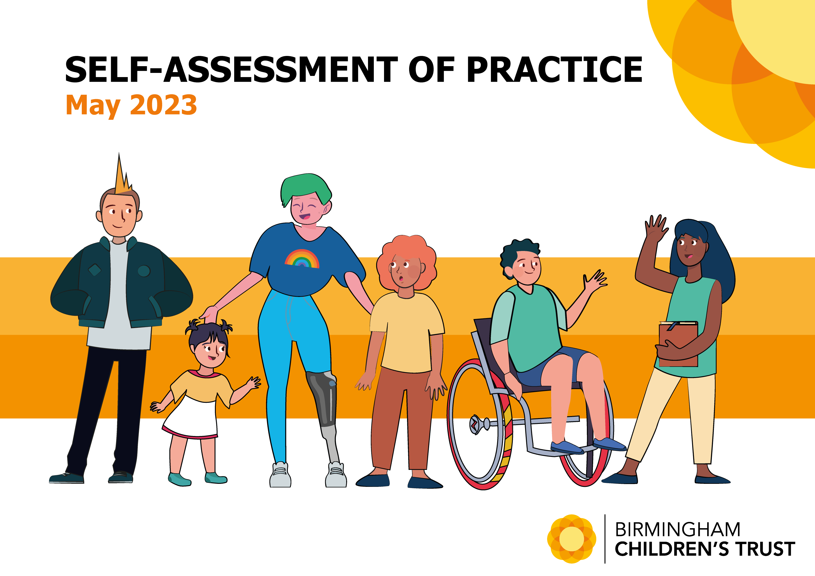

Contents
1. | Introduction and relationship with the wider children’s partnership | 3
2. | Overview of our progress | 4
3. | We know ourselves well - our test of assurance  3.1 Feedback from children and families – Rights, Advocacy and Participation Service  3.2 Our Profile | 6  7  8
4. | Quality and impact of practice  4.1 What we can evidence  4.2 Our challenges and continual improvement journey | 14  14  15
5. | Conclusion and next steps | 17
6. | Appendices  Appendix 1: Stronger Families: our offer to children and families  Appendix 2: The Trust Improving Supply Programme  Appendix 3: The Trust Practice Model – Connections Count  Appendix 4: Trust Development Plan  Appendix 5: Ofsted Action Plan  Appendix 6: Our Journey to ‘good’ | 18  18  20  21  23  23  23

- Introduction and relationship with the wider children’s partnership
Children’s social care services in Birmingham are delivered by Birmingham Children’s Trust. The Trust is owned by, but operationally independent from, Birmingham City Council. The Trust Board, chaired by Andrew Christie CBE, is fully operational and embedded. A detailed contract which includes finance, performance and governance is in place. Andy Couldrick, the Chief Executive of the Trust and the three Trust Executive Directors are responsible for the delivery of the contract. The Director of Children’s Services (DCS), Sue Harrison, is responsible for the commissioning of the Trust. The DCS provides strategic and systems leadership for education and SEND in the Council.
The Trust has just completed its fifth year of its contract. A new ten-year contract has been agreed with a five-year review incorporated.
The formal governance and commissioning arrangements established in the contract work effectively. Our recent ILACS inspection found clear and effective governance arrangements between the Council and the Trust and that political leaders give great priority to children. Also, that despite the financial pressures the Council faces, investment in strengthening services in response to increased demand is a continuing commitment.
The Trust and Council work together in a variety of other contexts, including the Safeguarding Children Partnership, the Children’s Partnership, the Community Safety Partnership, the SEND Board, and the Early Help Partnership. We know that a key area of weakness in the delivery of effective children’s services historically has been the absence of a coherent partnership. We are proud of the progress we have made; validated through our inspection finding that there has been a positive shift in the quality and impact of partnership working across the city.

- Overview of our progress
The Trust’s vision is to build a service that provides excellent children’s social work and social care services for the city’s most vulnerable children, young people, and families. Our values and principles remain the same – to work in partnership with families, putting the welfare of children at the heart of our business by listening to their wishes and feelings and acting in their best interests. Understanding the trauma that families face and supporting recovery through relationship-based practice remains central to our work. Our services are developed and delivered with these principles in mind. We know that to aid recovery our children and families need effective help and support.
Over the last five years, through our strengthening families programme, we have developed a comprehensive range of services to deliver our aspiration of supporting children to live with their families where it is safe for them to do so. Where this is not possible, our dynamic sufficiency planning endeavours to provide a broad range of alternative nurturing care options.
The Ofsted inspection of children’s services in December 2018 found that services for children required improvement to be good. A focused visit to the front door of Children’s services in January 2020 saw further improvement, as did the focused visit to services for children in care in October 2021. Our Fostering Service and our Adoption Service are judged to be good. Our recent ILACS inspection, published April 2023 found us to be good across all judgement areas. Inspectors found that much progress has been made by Birmingham City Council and Birmingham Children’s Trust in improving the experiences and outcomes of our children. Furthermore, that our chief executive and director of practice have a clear understanding of the main challenges they face and are working well with the DCS in meeting these. Inspectors also recognised that the Trust has made strong progress in most areas which required improvement at the last inspection, and that pace has been sustained through the pandemic and beyond.
We are extremely proud that our inspection findings are well-aligned to our own self-evaluation. We are also very proud of what we have achieved, but our aspiration and commitment to improve further does not waiver. We have developed a comprehensive action plan to respond to the findings from inspection and our own learning. We also have an ambitious Trust Development Plan. A key priority in this is to deliver our Child’s Journey Project to ensure our organisation fully supports our values and underpins our practice model.
Our aspiration is to provide the best possible help and support for the children, young people, and families that we serve, and this work will support and refine our delivery model to do that; reducing hand over points for children and encourage enduring and strong relationships.

- We know ourselves well - our test of assurance
We know that learning from practice is not one dimensional. We use the work collated by the Practice Hub to triangulate our thinking and provide assurance of grip – audit, practice evaluation, dip sampling, comments, compliments and complaints, performance and intelligence, surveys and feedback sessions all contribute to our overall understanding.
Birmingham Children’s Trust is a large system, we continue to work hard to ensure a consistent response to practice. The role of our Principal Social Worker, our psychologist and the Practice Hub is key in supporting the practice ethos. The Practice Hub provides a range of resources for Trust colleagues, supporting the importance of learning and development for staff including:
- Developing and updating tools, resources, practice standards and practice guidance to support effective practice
- City-wide practice forums and webinars
- Coordination and evaluation of Practice Evaluations and audit and the learning from such

Our practice evaluation approach is predicated upon the practitioner sitting down with a manager other than their own and the two reviewing the child together, in large part in conversation, but also with the practitioner showing the evaluator key documents in the child’s records to evidence their work. We also strive to triangulate information seeking feedback from parents, carers, or the young person and from professionals.
This approach has achieved a number of objectives. We have moved away from a focus on compliance and perusal of the child’s record alone to a focus on practice and the experience and progress of children. Our approach is more engaging and collaborative and as such a better vehicle for collective reflection and learning. It aligns with our relationship-based practice model.
We are ambitious and always want to know more. We need to fully embed quality assurance activity in every service area across the Trust. A key focus for the coming year is to fully embed communities of practice, to provide our staff with the opportunity to reflect on their own practice learning in a safe and enabling space, building on learning from our bespoke practice supervisor development programme. We also know we have more to do to ‘close the loop’ for individual learning and improve the confidence and skill of our team managers completing practice evaluations.

  - Feedback from children and families – Rights and Participation Service
We place the voices of children and young people at the heart of what we do. We have a dedicated Rights and Participation Service. We have nine groups and forums who work alongside the Participation Strategy group delivering our Participation Strategy. Key achievements include:
- The use of advocacy across the Trust has increased during 2022/23. There has been a 60% increase in young people accessing the service, this has improved the quality of the child’s voice at their meetings, especially at FGC and children in care reviews and this provides some mitigation against the low number of formal complaints
- We have a strong apprenticeship offer in the Trust
- Young parents have worked with health colleagues to develop a perinatal pathway. Our Young Parents are now shaping the multi-agency regional offer to new parents through our coproduction work with Birmingham and Solihull Clinical Care Group’s work
- Consultation with young people on ‘What makes a good and stable relationship’ has influenced the Trust’s enhanced practice model – Connections Count and Trust Practice Standards
- Our ‘Future You’ Films launched at the IMAX in Birmingham, which now provide a platform for training and workshops about being in care and leaving care and the importance of supporting our young people’s future education and employment opportunities
- Apprentice group have designed, bid, secured funding, and delivered their own holiday activity fund programmes to children in care, care leavers and unaccompanied asylum-seeking children. This was presented by one of our apprentices and showcased as good practice at the annual HAF conference in Birmingham
- Young people were specifically interviewed and filmed for training of the workers of the new Life Story project, this was delivered by our Childrens Rights Officer and Transformation apprentices. The second part of this training, sharing the views of birth parents, was co-presented by a birth parent
- Following targeted training with the Independent Review service, practice has been modified to include a short animation video for young people on the role of the IRO and review meetings. Additionally, each IRO should have their own profile which is shared with young people

  - Our profile

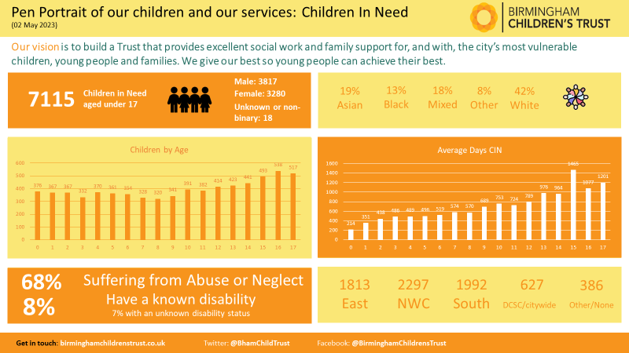
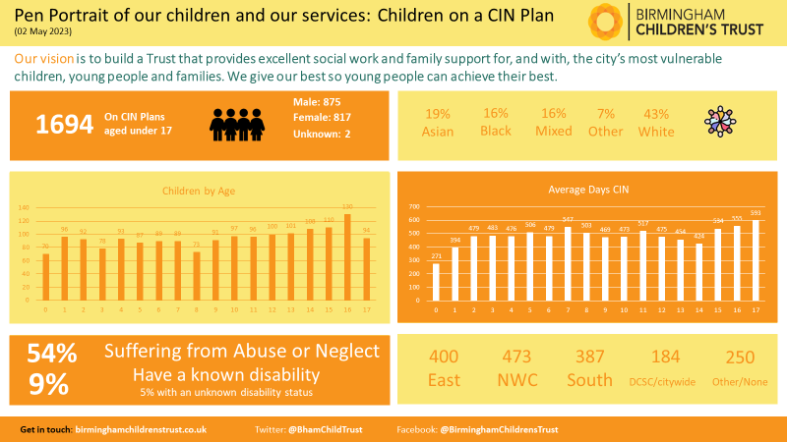
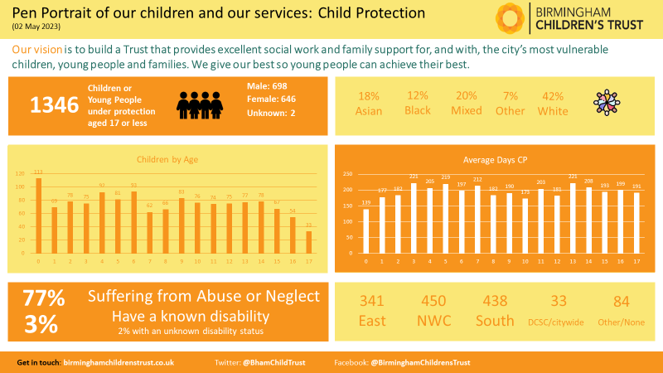
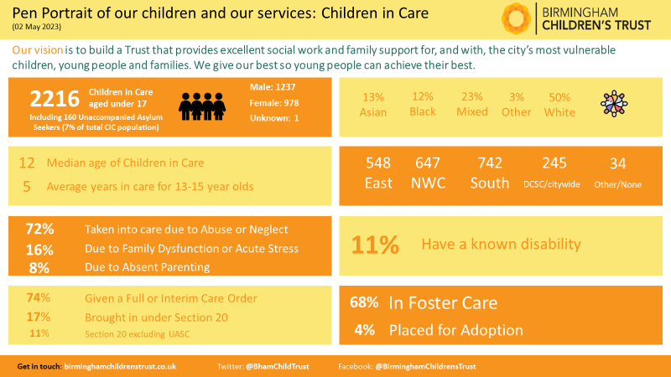
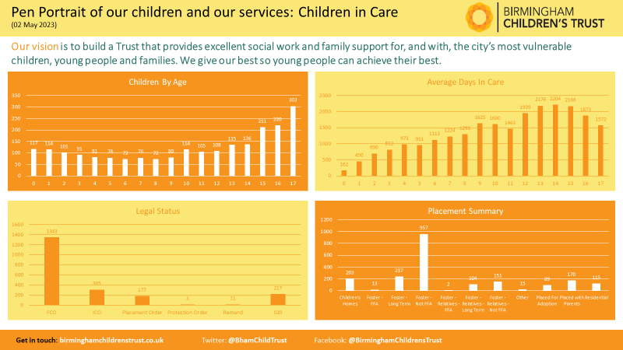
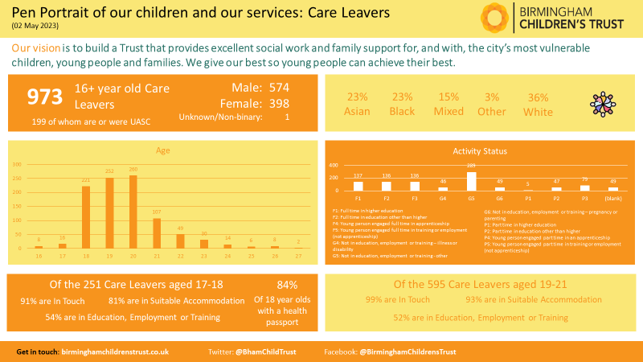

- Quality and Impact of Practice
4.1 In summary we can evidence
- A transformed and effective early help offer
- A safe and effective front door and emergency duty service
- Assessments of children’s needs are timely, and children are routinely seen as part of their assessment
- Thorough child protection enquiries and assessments. Fewer children’s plans end too quickly and very few plans last longer than they need to
- Core groups and reviews progress children’s plans
- Children receiving the help and support they need
- Social workers and family facing practitioners know their children. Work with children and their families is more purposeful and focused. Direct work with children routinely takes place and children are seen. For most children, we are making a positive difference in their lives
- Once children are identified as being privately fostered, they are seen and assessed in a timely way
- When children aged 16 or 17 present as homeless, they are quickly responded to
- Children at risk of exploitation are supported effectively
- Children come into care in a timely way and where it is their best interest; their identity needs are well considered
- Most care plans are appropriate and in line with children’s needs
- Care plans are regularly, thoroughly, and independently reviewed
- Most children in care live in stable and appropriate care arrangements, with few placed at a distance
- Children’s physical, emotional and mental health needs are well considered​ and they are well supported by the Virtual School
- Children in care experience stable relationships with their social workers, who visit them regularly and in line with their needs. Children benefit from age-appropriate direct work, which helps workers to gain their views. Children understand their family history and experiences
- Children are well supported to see those that are important to them
- Improved court timescales and improved quality of assessments resulting in fewer independent social work and expert assessments
- We have a strong offer for unaccompanied asylum-seeking children and care experienced asylum-seeking young people and adults
- Young people have pathway assessments and plans that are aspirational
- The majority of care experienced young people live in suitable accommodation and are in education, employment, or training at a higher rate than national and statistical comparators
- Most young people have good access to their health records, are registered with a GP and can access health services as required
- Care experienced young people have a range of forums through which to promote their voices and share their experiences with us
- We demonstrate continual improvement - both in practice and in creating the conditions for best practice to develop
- We are strong innovators and swift to identify and respond to emerging issues; adding additional resources to support frontline practice and outcomes for children and families. For example, our new Ascent Team for children with enduring and complex mental health issues
- We are proud of our broad range of help and support services for children, young people and their families
- We are strong corporate parents
- We are developing a strong learning culture. Our social work Academy offer is continually improving, and our staff have access to a comprehensive and broad range of training
- Our staff receive regular supervision which is increasingly reflective. This is not always consistently demonstrated in children’s records but is improving
- Our practice weeks have connected senior leaders to practice as well as enhancing our quality assurance system
- We know ourselves well
4.2 Our challenges and continual improvement journey
- We are still grappling with the legacy of the Covid pandemic, the challenges for families due to the increase in cost of living and the impact of wider contextual and community risks
- Making sure that we are responding effectively and in a timely way to the emotional health and wellbeing of our children and young people in the context of rising need for support services
- We have sought to develop the partnership response to the impact of domestic abuse on children and families. However, this remains under-resourced across the system to respond effectively to the increasing level of demand. The absence of perpetrator programmes for high-risk offenders is a known concern for us
- Our neglect strategy is in place, but we have more to do to fully embed our approach
- Our quality assurance arrangements are effective, but we have more to do to track the completion of recommended actions and to demonstrate the impact for individual children
- Supervision is held regularly, although it is not consistently effective in progressing children’s plans and addressing drift and so we have more to do to improve consistency and our recording of supervision in children’s records
- The quality of our work with children and their families is not always reflected in our written work. We need to continue to improve the SMARTness of our written plans
- The quality of practice and management oversight for progressing children through the pre-proceedings stage of the Public Law Outline (PLO) has improved. However, we need to fully embed our new approach, practice guidance and supporting templates to achieve timely legal permanence for all children
- Pre-birth assessments are of good quality but are not always commenced in a timely way. We therefore need to centralise our pre-birth teams and improve our timeliness
- We have reviewed and strengthened our offer to disabled children but recognise there is more to do to provide a stronger offer with our partners to children who have complex needs such as autism and enduring mental ill health. We are working closely with the council and partners to make sure that SEND children are consistently offered the correct levels of support
- We need to make sure our health partners have sufficient capacity to undertake consistently timely health reviews of our children in care
- We need to ensure that transition arrangements for children moving into Adult Services are timely and effective
- We are working hard to ensure that all children in our care live in good quality settings, this is a challenging area for us given the current market provision
- PAs develop strong relationships with our care experienced young people, but many would benefit from earlier allocation of a PA
- We face the same challenge as others across the region with recruitment and retention of social workers and PAs. Our Academy goes from strength to strength, and we are slowly becoming an employer of choice as a result. However, the ‘pull’ of agency and private companies, because of enhanced pay rates, still significantly affects us and impacts on our ability to keep workloads as low as we would want

5. Conclusion and next steps
The work of the Trust is complex and far reaching. We have continually evolved and broadened our help and support offer to give children the best option to remain in their families where it is safe to do so. The development of family hubs will further strengthen this.
There is one common thread throughout every one of our service areas – a determination to be better for the children and families whom we serve. We will continue to test ourselves and plan accordingly. Our Child's Journey programme makes sure that the experience of children and their families is at the heart of our thinking and our planning. We are mindful of, and already thinking about, the implications of the government response to the Care Review. The findings of which will inform our Child’s Journey Programme, which will be firmly rooted in and informed by our enhanced practice model – Connections Count.
Our workforce means a lot to us, we want them to have the right tools to do the best job. We will continue to focus heavily on supporting them to be clear, consistent, and confident in their practice. We will not always get it right for all children and families, but we are determined to learn from our children and families’ experiences and to ensure that the learning is disseminated Trust-wide and partnership-wide.
We know that the whole partnership must respond to the children’s agenda. We believe that a key area of our improvement over the last five years has been the full acknowledgement, through our system leadership, that we are part of a system and as such, partnership working in Birmingham is now a strength. We have an opportunity to further strengthen our relationship with the Council and galvanise the partnership even more through Birmingham’s Change for Children 2023-2028 agenda. We are determined that children’s needs are front and centre of all partners considerations not just ours.
We will continue to actively listen to children, families, our staff, and our partners, we will continue to provide stable leadership to the Trust and wider. We will continue to do the best that we can for everyone who uses our services during these uncertain and unprecedented times.

Appendix 1 Stronger Families: our offer to children and families
Key Elements:
- Children do best when growing up safely in their birth families.
- When parents are unable to safely care for their children, the search for alternative care starts with the child’s family and friends, and if there is none available, seeks alternative nurturing care.
- All our work with families is relationship-based and increasing trauma-informed (based on the simple premise that we ‘do with’ children and families, rather than ‘do to’ or ‘do for’).
The initiatives and programmes we have introduced reflect our approach to supporting families by complementing social work practice meeting need at the earliest point and preventing escalation
Project/Activity | Description/ Impact
Early Help | Multi-agency work with families to prevent escalation of needs and referral on to social care.
Pathfinder | School-based and joint-funded Early Help programme: 45 schools plus CoBS (PRU). Reduction in referrals to social care and improved outcomes.
Preparation for Adulthood &Transitions | Joint programme with Adult Services: transitions and support for young people reaching adulthood and needing ongoing support to live independently.
Family Group Conferences | From 50 FGCs a year during 2020 to 368 between April 2021 and September 2022
Social Work Practice Model | Relationship-based and trauma-informed practice model, recognising importance of families, relationships and wider systems in which children live
Multi-systemic Therapy | Intensive intervention with high-risk young people and their families, focused on reducing risk behaviours and avoiding family breakdown.
Contextual Safeguarding Hub ‘Empower U’ | Multi-agency hub centring our work with young people at risk of being missing, exploitation, and exploitation related serious youth violence. Joined-up targeted approach to managing risk and addressing environmental factors. Working with families as protective factor for young people. Reducing consequence of exploitation on family breakdown.
Family Drug and Alcohol Court | Specialist court dealing with substance-misusing parents/families where DA is an issue, to keep children safely in their care where we would otherwise be seeking removal.
Reuniting Families | Programme aimed at returning children from care safely back into their families.
Moving on Programme | Working in partnership with BERRI psychology (berri.org), using their evidence-based assessment tool, associated reports, advice, and targeted clinical support to identify, match and transition children into family-based care environments where appropriate and safe. This will include foster families but also includes moves from residential care to the wider birth family /child’s network where suitable. Building on the IFA market to ensure capacity is available to meet need for this project.
Safer Families | Partnership with a voluntary organisation providing intensive, volunteer-based support to families at risk of breakdown. Reducing risk of need for alternative care.
Breaking the Cycle | Programme owned by the Trust working with parents who have lost previous children to the care system to enable them to make different choices about their futures and/or to care more safely for further children.
Lifelong Links | Project that reconnects older young people in care and care leavers to family networks/important adults in their lives. Leads to lasting support networks and, for some, a swifter exit from care.
Families Together Plus | Services supporting children on the ‘edge of care’ to stay with their families – a seven-day service.

Appendix 2 The Trust Improving Supply Programme
Project/Activity | Description/Intended Impact
Family & Friends Care | Care provided by a relative when a child cannot live with parents. Since 2018 the Trust has doubled the rate of children in family and friends care to 11%: still below the national average use of this care type but a further 1% increase since September last year.
Foster Carer Recruitment | Improved recruitment: through increased marketing and recruitment activities, including a new Fostering Microsite, has resulted in a net increase in mainstream foster carers of 9.2% over the past three years.
Regional Adoption Agency/Strategic Partnership | Innovative partnership with a Voluntary Adoption Agency will improve supply of local adopters and reduce cost of inter-agency fees paid currently. In this financial year, the use of internal adopters has increased by 32% compared to the same point in the previous year.
Improved Residential Commissioning | Reversing out of high-cost, poor performing block contract; reducing urgent spot-purchasing; improving cost and contract management; building new provider alliances to improve VfM and quality.
Recommissioning Supported Accommodation | Moved to a new commissioning partnership, working with a local vol. org. and Adult Services to provide stronger placements at better value.
Tripartite Funding Agreement | For children in care with complex needs, funding contributions from NHS and BCC Education (DSG) are lower than in other systems. So disproportionate costs fall to the Trust. Leveraging a more equitable funding model will reduce the burden that falls to the Trust. Our work in this area is beginning to show effect.

Appendix 3 The Trust Practice Model – Connections Count
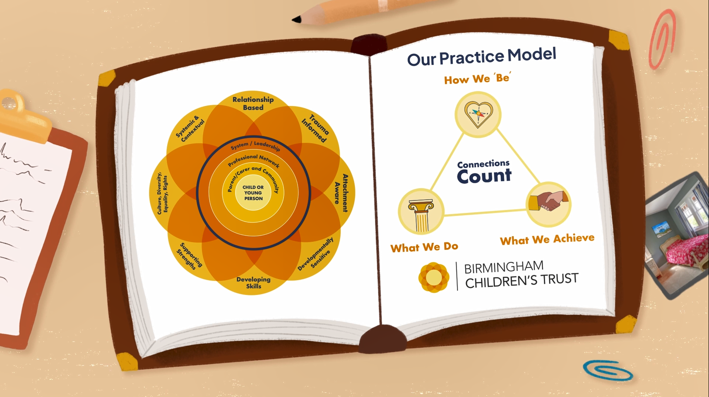
Our Relationship Based Practice Model “Connections Count”

We provide a wide range of services to children, young people and families who have often experienced significant adversity, life stress, significant attachment disruption, trauma or structural inequalities; and who may find it difficult to have a felt sense of safety or trust when working with professionals or those in positions of power. We recognise that the more that we understand about the impact of these experiences and the risks they can create, the more we can pro-actively work together to create the counter conditions needed for positive change, resilience and recovery.

We work tirelessly to instil the values that we believe support effective social care and social work practice Trust-wide. Our organisation is open to learning, reflection, and change. We are talking constantly about our practice with each other and with our children and families, reinforcing our values and behaviours. We have aligned our extensive training offer so that we constantly reinforce our model in all that we do. We provide a therapeutic support offer to practice, supporting the Trust workforce psychologically, helping us to provide a safe and held workforce to ensure resilient staff.

The principles of a relationship based, and trauma informed practice approach also applies to our staff wellbeing strategy. We recognise the emotional impact of this work on staff and teams and provide a wide range of initiatives to support wellbeing and resilience within the workforce.
The Trust has always placed children and supportive relationships at the heart of our practice. However, we have further developed our Practice Model to provide a clearer and more consistent language and organising framework for practice that more explicitly names the golden threads (underlying principles) of our approach.

The model centres the voice and lived experience of the child or young person, whilst recognising that children and young people don’t live, grow or function in isolation. Sometimes to best support them, we must also work to support their parents/ caregivers and work together with communities and partner agencies. The model is underpinned by the following golden threads or core principles: Relationship based, trauma informed and attachment aware; providing services that are developmentally sensitive (understanding impact of adversity on child development, recognising needs at different ages and developmental stages, and supporting special educational needs and disabilities); support the development of new skills and existing strengths; are respectful of and sensitive to issues of culture, diversity, equality and rights; and aim to understanding family struggles in the context of the wider situations, communities, systems in which they live.

These golden threads underpin:
- How We ‘Be’ – the heart of our relational approach
- What We Do – our 4 Pillars of Practice
- What We Achieve – creating positive change and improving children’s lives

Our organisation is large and diverse so we also respect that within each service area, there may also be additional approaches, frameworks or toolkits that are specific and appropriate to the work they do.

Appendix 4 The Trust Development Plan

Appendix 5 The Trust Ofsted Action Plan

Appendix 6 Our Journey to ‘Good’
Our Chief Executive has always been clear that we have never had ‘bad’ or ‘poor’ social workers in Birmingham; it was the historical conditions within which they were working that negatively impacted upon the quality of practice.
The key ingredients that have helped us to create the conditions within which good practice can thrive are:
- Stability in the strategic and wider leadership team
- Effective governance arrangements both with the Council, as our commissioner, and internally as an organisation
- Having a consistent and respected ‘presence’ in the wider partnership to influence the children’s system
- Having clear, consistent and a well-communicated vision, rooted in our values – for children to grow up in their own families where it is safe to do so and, where this is not possible, for our children to experience stable nurturing care
- Transforming early help to support families at the earliest opportunity
- The creation of a broad range of responsive and effective help and support services tailored to assessed need
- Having a secure practice model that is continually enhanced and rooted in relationships and increasingly trauma-informed
- Setting clear standards for practice and measuring ourselves against these
- Knowing ourselves through effective use of quality management and performance information and regular and reliable auditing
- Being responsive to pressures in the system or new/emerging issues
- Creating stability in the workforce and making sure our ‘offer’ to our staff meets their needs in terms of remuneration packages, support to practice, staff wellbeing and quality/accredited opportunities for continuing professional development
- Growing our own through our forever growing practice academy
- Celebrating success with our workforce

Appendix 1 – Our strengthening families approach
Appendix 2 – Our improving supply programme
Appendix 5 – Ofsted Action Plan
Appendix 4 – Trust Development Plan
Appendix 3 – Our enhanced practice model

