STATEMENT OF PURPOSE FOR YEAR 2023-2024
BIRMINGHAM CHILDREN’S TRUST ADOPTION AGENCY

1 INTRODUCTION

The Statement of Purpose sets out the core aims and objectives of Birmingham Children’s Trust Adoption Agency*.

*This agency was formerly the Birmingham City Council Adoption Agency. On the 1st April 2018 Birmingham transferred its children’s social work services into the Birmingham Children’s Trust which is a community interest company wholly owned by Birmingham City Council.

Birmingham Children’s Trust Adoption Agency is a Voluntary Adoption and Adoption Support Agency which is set within the Birmingham Children’s Trust.

The Statement of Purpose fulfils the requirement for adoption agencies to compile a statement detailing how the service will meet outcomes for children, the range of services provided, the governing principles and who manages and provides services.

The statement of purpose is intended for:

Children and young people
Birth relatives
Prospective and approved adoptive families
Social workers
Councillors
Members of the Birmingham Children’s Trust
Adoption Panel members
Regulation through Department for Education (Ofsted)
Members of the public

The statement of purpose will be reviewed annually through the applicable governance processes of Birmingham Children’s Trust which is accountable to Birmingham City Council.

2 MISSION STATEMENT

Birmingham Children’s Trust Adoption Agency is committed to providing permanency through timely and quality adoption for the children and young people of Birmingham who need to be adopted.

Proactive advice, training and practical support is provided to care planners ensuring their duty to consider early permanence (EP) for children in care is met. The Children’s Trust has committed to adopt the Midlands Together Collaboration Early Permanence Practice Standards in spring/summer of 2023, which aims to standardise practice among multi-agency partners across the midlands of England.

Early Permanence placements are made and supervised in close partnership with Birmingham Children’s Trust Independent Fostering Agency (IFA) subject to all applicable National Minimum Standards and statutory regulations.

The BCT IFA Statement of Purpose can be found here:
Birmingham Children's Trust Fostering Service - Statement of Purpose 2021-2022 | Birmingham Children's Trust (birminghamchildrenstrust.co.uk)

The Agency is committed to ensuring that children and young people will be adopted by families who have been assessed and approved as suitable to providing a secure, warm, safe, and supportive environment in which they can develop in all aspects of their lives.

3 AIMS AND OBJECTIVES OF BIRMINGHAM CHILDREN’S TRUST ADOPTION AGENCY

Birmingham Children’s Trust Adoption Agency aims to provide a service for all its customers that is welcoming, user friendly and non-discriminatory.

Provide a range of safe, secure, and enduring adoption placements to meet the assessed needs of children needing permanent placements to promote and safeguard their welfare.

Ensure that adoptive placements promote stability and positive outcomes for children by working in partnership with adopted children and young people, adoptive parents, birth families and other professionals in the adoption and adoption support process.

Meet the timescales set out in the Children Act 1989, Statutory Adoption Guidance revised in February 2011 and July 2014 and the Adoption Minimum Standards. The Statement of Purpose fulfils the requirement of Standard 18 of the Adoption National Minimum Standards 2014, Regulation 2 of the Local Authority Adoption Services (England) Regulations 2003, Adoption Support Agencies (England) and Adoption Agencies Regulations 2005 and the Adoption and Children Act 2002.

The Adoption agency will provide a high quality and comprehensive range of adoption and adoption support services that meet the needs of children and young people needing to be adopted, prospective adopters, adoptive families, birth families, adopted adults and the public.

The core objectives are to:

Provide permanency for children and young people through recruiting, assessing, and providing a suitable and diverse range of families to meet the needs of children and young people who need to be adopted.

Recruit a sufficient pool of prospective adopters to offer placement choice to meet the assessed needs of the children and young people needing adoptive families currently and to meet future needs.

Support families post-linking to ensure placements succeed, ensuring that every child being placed for adoption has an Adoption Support Plan in place and ensure that any parties to adoption are provided with an assessment for adoption support services, if requested.

Develop a range of adoption support services, including practical, financial, and therapeutic services, in partnership with other relevant agencies, to ensure placements succeed.

Employ staff with appropriate and sufficient skills, knowledge, and experience to deliver the adoption service.
4 VALUES WHICH UNDERPIN BCT ADOPTION

The values which will underpin the Service are those outlined in the Adoption Minimum Standards 2014:

VALUES – CHILDREN

  - The child’s welfare, safety and needs are at the centre of the adoption process.

  - Adopted children should have an enjoyable childhood, and benefit from excellent parenting and education, enjoying a wide range of opportunities to develop their talents and skills leading to a successful adult life.

  - Children are entitled to grow up as part of a loving family that can meet their developmental needs during childhood and beyond.

  - Children’s wishes and feelings are important and will be actively sought and fully considered at all stages of the adoption process.

  - Delays should be avoided as they can have a severe impact on the health and development of children waiting to be adopted.

  - A sense of identity is important to a child’s well-being. To help children develop this, their ethnic origin, cultural background, religion, language, and sexuality need to be properly recognised and positively valued and promoted.

  - The needs of disabled children and children with complex needs will be fully recognised and considered.

  - Where a child cannot be cared for in a suitable manner in their own country, intercountry adoption may be considered as an alternative means of providing a permanent family.

  - Children, birth parents/guardians and families and adoptive parents and families will be valued and respected.

  - A genuine partnership between all those involved in adoption is essential for the NMS to deliver the best outcomes for children; this includes the Government, local government, other statutory agencies, voluntary Adoption Agencies and Adoption Support Agencies.

VALUES – ADOPTED ADULTS AND BIRTH RELATIVES

  - Adoption is an evolving life-long process for all those involved – adopted adults, and birth and adoptive relatives. The fundamental issues raised by adoption may reverberate and resurface at different times and stages throughout an individual’s life.

  - Adopted people should have access to information and services to enable them to address adoption related matters throughout their life.

  - Agencies have a duty to provide services that considers the welfare of all parties involved and should consider the implications of decisions and actions for everyone involved.

  - Agencies should seek to work in partnership with all parties involved, taking account of their views and wishes in decision-making.

  - Agencies should acknowledge differences in people’s circumstances and establish policies that provide non-discriminatory services.

  - Adopted adults have their adoptive identify safeguarded and the right to decide whether to be involved in contact or communication with birth family members.

5 THE NAME, QUALIFICATIONS AND EXPERIENCE OF THE RESPONSIBLE INDIVIDUAL AND REGISTERED MANAGER

Mrs. Lisa Jamieson (nee Omar) who is the Assistant Director for Specialist Services which includes Placements, Commissioning and Corporate Parenting. Lisa holds an MA in Social Work Studies gained in 1996 and has worked in Local Authorities since this time. She has an NVQ level 4 in Management and is registered with Social Work England.

The Registered Manager is Mr Andrew J. Logie who is the Adoption Head of Service and Leader of the Regional Adoption Agency. He has 22 years’ experience working in social care. He holds a Degree in Social work, BSc (Hons), Post Qualifying Award in Child Care and Child Protection, a Postgraduate Diploma in Law, is a Signs of Safety Leader Champion, and is registered with Social Work England.

Address: Adoption Agency Manager
Birmingham Children’s Trust
1 Lancaster Circus
Birmingham
B4 7DJ

NB: The Assistant Head of Adoption, Mrs. Jane Francis is the Agency Adoption Support Services Adviser (ASSA).

The Adoption Agency Decision Maker (ADM) is:

Lisa Jamieson, Assistant Director for Specialist Services which includes Placements, Commissioning and Corporate Parenting.

6 STAFFING

The list of current staff and their relevant qualifications and experience will be made available to the Ofsted Inspection Service on request.

Structure chart of the agency:

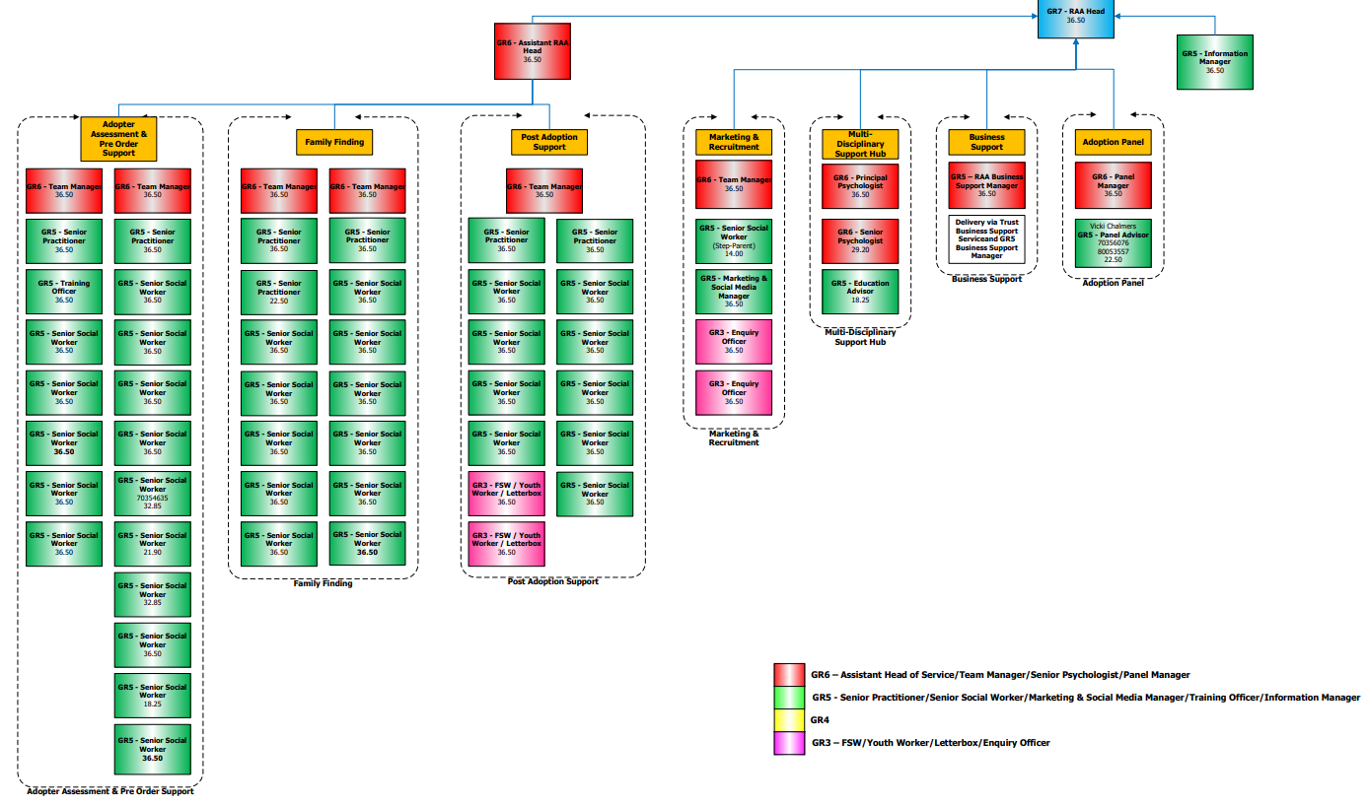

7 MONITORING ARRANGEMENTS TO ENSURE EFFECTIVENESS AND QUALITY

Systems are in place to monitor and evaluate the provision of services. These are:

- All staff receive regular supervision and an Annual Appraisal.

- All prospective adopters complete an evaluation of the preparation training. They are asked to provide feedback on their experience of attending Panel and of their general experience of the adoption process.

- Prospective adopters are advised of the Departmental and Corporate Complaints Procedure and the Independent Review Mechanism.

- Children’s permanence plans are monitored through the LAC Review process and regular adoption monitoring meetings.

- An audit of practice is measured against the National Standards every six months in the Adoption Agency Report.

- Timeliness monitoring reports and statistics are provided to the Executive on a six-monthly basis.

- Since November 2020 the Adoption Service has provided an regular online survey for adopters and prospective adopters who have accessed the service to gain feedback on their experiences. This is offered at various stages of the adoption journey, with feedback being collated quarterly and service developments being shaped by feedback.

8 THE PROCEDURES FOR RECRUITING, PREPARING, ASSESSING, APPROVING AND SUPPORTING PROSPECTIVE ADOPTERS

- The main consideration for the Adoption Team will be to provide adoptive families for children to enable them to grow up in a secure and positive environment which will give them the best opportunity to fulfil their potential.

- To achieve this we aim to recruit, assess, and approve adopters in a robust and timely manner to meet the needs of children awaiting placement.

- Prospective Adopters will be expected to attend comprehensive training and preparation groups where they will be able to learn about the tasks and challenges of adopting and can meet with adoptive parents.

- Adopters hoping to adopt from overseas will be referred to ‘The Inter-Country Adoption Team’ for specialist adoption groups.

- Prospective adopters will have an allocated social worker for the assessment/home study and, wherever possible, the same social worker will be allocated throughout the process to adoption.

- The application will be considered by the Agency Permanence Panel which is constituted in compliance with the Adoption Agency Regulations 2005. The Adoption Agencies and Independent Review of Determinations (Amendment) Regulations 2011. The Panel will make a recommendation to the Agency Decision Maker for approval or a qualified determination (if the applicant is not approved).

- Where children cannot be placed within the Agency’s own resources, the Adoption Team will seek to make appropriate and suitable arrangements with other adoption agencies and referrals will be made to Adoption Link three months (in most cases) after approval to adopt in agreement with adopters, where Birmingham Children’s Trust is not actively considering a local match with adopters.

- The Adoption Agency will not exclude any applications based on lifestyle. All applicants will be medically assessed. Smoking, weight, alcohol consumption, previous illnesses, criminal convictions, and family history will be discussed in the initial enquiry stage. Adopters who proceed to application will be assessed and a report presented to Panel. A recommendation by Panel will be made as to whether the prospective adopter will be likely to be able to provide a secure home for a child to grow up in.

- All applicants will be treated with respect and all enquiries and discussion will relate to their ability to offer a secure home to a child needing adoption

- A post approval pack of information covering the Matching, Introduction and Placement process is available to approved adopters.

- INTERCOUNTRY ADOPTION

- Inter-country adoptions take place in the best interests of the child and may be considered as an alternative means of providing a family for a child who cannot be cared for in a suitable family, for a range of reasons in his/her own country. For any prospective inter-country adopter to be considered, they must be eligible under UK law and eligible under the law of the country to which they wish to apply. Safeguards and standards equivalent to those which apply in domestic adoption are also applied in Inter-country adoption to protect the welfare of the child concerned.

- NON-AGENCY ADOPTION

- Non-agency adoptions are processed in line with statutory requirements. Applicants are given support and advice on the process and an allocated worker will undertake the assessment and complete the report for the court.

Further information, including timescales is available for prospective adopters and overseas adopters from the Adoption Team.

Information on adoption is available online at: www.birminghamchildrenstrust.org.uk

The following leaflets are also available from the Adoption Team:

- Complaints Procedure
- Children’s Guide to Adoption & Adoption support
- Information leaflet for Adopters Attending Panel
- Information about the Letterbox system
- References

- ADOPTION SUPPORT SERVICES

- Adoptive families, adoptive parents, adopted people and birth parents can apply to the Adoption Support Team for an assessment of need for adoption support.

- The service provides an administrative letterbox exchange system. Advice and support are available to birth parents and adoptive families to assist with the letter exchange. In addition, support, advice, and assistance is available to children and the adults involved in any direct contact.

- An Initial assessment will be carried out and if the identified need can be met then support will be offered, or the applicant will be signposted to an appropriate provider.

- Assessed therapeutic need will be accessed via the Adoption Support Fund.

- If a more complex need is apparent, a social worker will be allocated, and a specialist assessment will be undertaken.

- Birmingham provides adoption support and commissions a service for birth family from Family Action, which can be contacted as below:

PAC-UK
Hollyshaw House
2 Hollyshaw Lane
Leeds
LS15 7BD
Telephone: 0113 264 6837
E-mail: advice@pac-uk.org

10 ADOPTION SUPPORT FUND (ASF)

On 1 May 2015 the Adoption Support Fund (ASF) became available to adopters throughout England.

The fund was established for families to access therapeutic support.

The process:
- Adopters may approach Birmingham Children’s Trust for an assessment of their adoption support.
The local authority that places the child is responsible for assessing adoption support needs for three years after the adoption. After that, it becomes the responsibility of the local authority where adopters live.
- Birmingham Children’s Trust assesses if therapeutic support is needed, the type required and if this support is eligible for payments from the fund.
- The adopter and Birmingham Children’s Trust will look at the support that is available.
- Birmingham Children’s Trust applies directly to the Adoption Support Fund on behalf of the adopter.
- The Adoption Support Fund approves the funding, and the funds are transferred to Birmingham Children’s Trust who then purchases the support.

Who is eligible?

- The ASF is available to all children adopted from care and not just newly adopted children.
- The ASF will pay for pre- and post-adoption order support for children adopted from care in England or living in England having moved from care in Wales, up to age 18 (25 with an EHC Plan). It is also available for children adopted from overseas or for children previously Looked After who are placed with Special Guardianship Order carers.
- It is not, as with several other elements of adoption support, applicable to non-agency adoptions.

What sort of support will the ASF pay for?

- The fund will pay for therapeutic services that are not available within Birmingham Children’s Trust. These include Dyadic Developmental Psychotherapy and Theraplay® among others.

- Advanced, therapeutic parenting courses can also be funded by the Adoption Support Fund.

CONTACT DETAILS:

Birmingham Children’s Trust Post Adoption Support Social workers can be reached by telephone or in writing at the address and telephone number below:

Post Adoption Support Team
1 Lancaster Circus
Birmingham
B4 7DJ

Tel: 0121 303 1010

Email: DutyPostAdoptionSupport@birminghamchildrenstrust.co.uk

11 INFORMATION ABOUT THE COMPLAINTS AND APPEALS PROCEDURE

In seeking to constantly improve the quality of the adoption service, we welcome and encourage feedback from service users, providers, and partner agencies. Prospective adopters will be given written information about the Directorate Complaints procedures and given information about how to make a complaint. The Communications Manager (Complaints) provides intervention, problem solving, independent investigation and mediation.

Customer Relations Service (Complaints)
Birmingham Children’s Trust
1 Lancaster Circus
PO Box 17342
Birmingham
B2 2DW
Tel: 0121 303 5161, Option 2
cypfsscustomerrelations@birminghamchildrenstrust.org.uk

Complaint information can be provided in large print, Braille, audio tape or in another language on request to the Complaints Manager

Applicants to become adopters who are not accepted for approval on the recommendation of the Adoption Panel and/or the decision maker can make further representations through the Agency procedures or are able to ask for their case to be reviewed by the Independent Review Mechanism (IRM). Details of this process are made available to applicants during preparation and assessment.

The IRM has the following timescales:

- Applicants have 40 days from the agency decision to contact the IRM.

- The Adoption Registered Manager is the appointed liaison officer and will be contacted to produce relevant documents within 10 days.

- The IRM will set up a panel within 3 months of the application.

Contact details are:

IRM
Contract Manager
Unit 4
Pavillion Business Park
Royds Hall Road
Wortley
Leeds, LS12 6AJ

Tel: 0113 202 2080 or 0845 450 3956

Opening Times: Mon – Weds 9am – 5pm
Thurs & Fri 9am – 1pm

irm@irm.org.uk

Applicants who receive a qualifying determination will receive information in writing about the options available to them prior to a final decision being made.

Birmingham Children’s Trust Liaison Officer is Vicki Chalmers, Vicki.Chalmers@birminghamchildrenstrust.org.uk

  - DETAILS OF THE REGULATOR, OFSTED

On 1st April 2007, Ofsted took over from the Commission for Social Care Inspection (CSCI). Ofsted is now responsible for monitoring, regulating, and inspecting adoption services under the provision of the Care Standards Act 2000.

Web address: www.ofsted.gov.uk
Tel number: 0300 123 1231

HQ Address: Ofsted
Piccadilly Gate
Store Street
Manchester
M1 2WD
Email: enquiries@ofsted.gov.uk

Children’s Commissioner for England:

Dame Rachel de Souza
The Office of the Childrens Commissioner
Sanctuary Buildings
20 Great Smith Street
London
SW1P 3BT
Telephone: 020 7783 8330
Info.request@childrenscommissioner.gsi.gov.uk

NB: Birmingham’s 2022 adoption agency inspection is available on request or by visiting:

http://www.ofsted.gov.uk/local-authorities/birmingham

