**Introduction and context**

We work in partnership with families, putting the welfare of children at the heart of our business by listening to their wishes and feelings and acting in their very best interests. Understanding the trauma that families face and supporting recovery through relationship-based practice remains central to our work. Our services are developed and delivered with these principles in mind. We have achieved a great deal as a Trust, by improving practice and by influencing the wider children’s system. We have developed a number of new and exciting services that focus on making a difference to children and families. We know that there is always more to do.

Our priorities for 2023/24 reflect a balance between ambition to innovate and continually develop our offer, and the need to consolidate and embed what we have done already. We will continue our relentless focus on doing well the things we must do to safeguard our children and promote their wellbeing, to support families, to keep children and their families together wherever it is safe to do so, and to create the conditions for good practice to flourish.

We have developed this plan through listening to the feedback of children, families, our partners, our workforce and taking account of our learning from our recent Ofsted inspection. We learnt much from our inspection, both in terms of Ofsted findings and feedback, and also, our own learning as we prepared for and navigated the inspection.

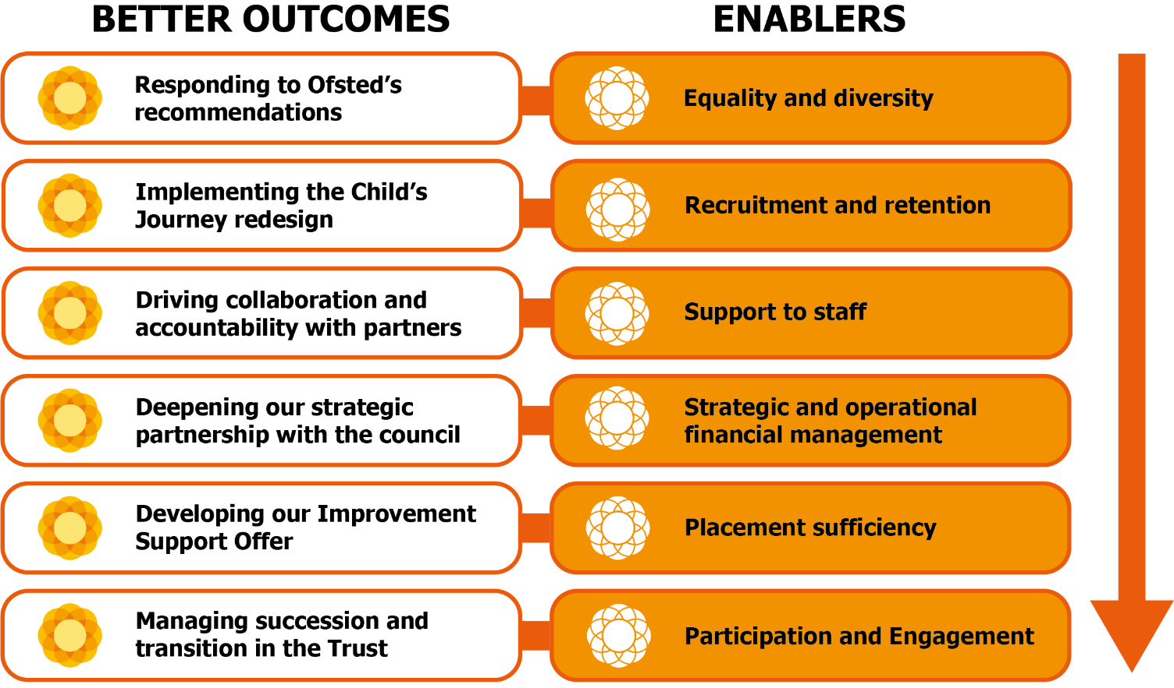

We remain ambitious for our children. We are delighted that Birmingham City Council has announced that 2023 will be the Year of the Child in Birmingham. The Trust will capitalise on this investment by making sure that our offer meets the needs of those who use our services.

**Development Plan 2023/2024**

Actions starred* are carried forward from the previous plan with amended timescales

**RAG status Key:**

**GREEN** On Target for delivery

**AMBER** Delays / Issues but delivery on course

**RED** Major Issues preventing delivery

**BLUE** Complete

**Actions starred* are carried forward from the previous plan with amended timescales**

|  |  |  |  |  |  |
| --- | --- | --- | --- | --- | --- |
| **Strategic Priority 1**  **Responding to Ofsted recommendations and continual practice improvement** | | | | | |
|  | | **Lead(s)** | **Date to complete** | **Progress update** | **RAG Status** |
| 1.1 | Implement our ILACS and YOS Inspection Action Plans | Director of Practice - Jenny Turnross | July 2023 | Action plans developed. ILACS action plan to be shared with Ofsted in the Annual Conversation (26 May). Governance through Extended Executive Meeting for ILACS action plan and YOS Board for YOS action plan |  |
| 1.2 | Re-invigorate the Child’s Journey Programme to better align services and strategic portfolios; and to reduce the number of hand-off points for children and families | Child’s Journey Programme Director - Alison Montgomery | March 2024 | New project manager in place and enhanced project plan in development. Work in train to align the child’s journey and practice model through a single project manager. |  |
| 1.3 | Fully embed the enhanced Practice Model – Connections Count across the Trust | AD Practice Improvement and Development – Di Partridge | March 2024 | Initial training has commenced and on target for completion for the whole workforce by end of July. Work in train to align the child’s journey and practice model through a single project manager. |  |
| 1.4* | Develop and implement Communities of Practice to ensure that front-line workers and leaders are supported, reflective, and aware of contemporary social work/ social care practice. | Director of Practice - Jenny Turnross /  Assistant Director - Alison Brown | March 2024 | PSDP communities of practice pilot commissioned. Delivery partner is Tavistock and Portman. Planning is linked to Child’s Journey work and future accommodation of the Trust in the city – due to ‘go live’ from September 2023. |  |
| 1.5* | Implement the Practice Academy and the Trust (Leadership and Management) Academy to maintain and develop skills across the Trust. Seek accreditation from the ILM. | Interim AD Practice Improvement and Development - Alison Brown | September 2023 | Leadership and management offer live on BCTA website. Work with ILM is ongoing in respect of accreditation.  Accredited Coaching qualification in place. 1st cohort running October 2022. |  |
| 1.6 | Strengthen SEND practice across the Trust and ready ourselves for SEND inspection; including recruitment to temporary SEND lead role | Child’s Journey Programme Director - Alison Montgomery | September 2023 | Recruitment to SEND lead role ongoing as we are struggling to find a suitably skilled and experienced candidate. SEND inspection project group set up and first meeting scheduled for 10 May. |  |
| 1.7 | Embed our approach to writing to children | Interim AD Practice Improvement and Development - Alison Brown | March 2024 | Writing to the child training developed and delivered through Practice Week (April). |  |
| 1.8 | Continue to embed our Participation Strategy so that collation of the voice of our children systematically informs our quality assurance functions and service design across all service areas; including rolling out the participation standards for services | AD Commissioning – Lisa Jamieson | March 2024 | Participation Strategy in place and operational delivery group in place. |  |
| 1.9 | Strengthen our front-line practice for children experiencing mental health issues (117 entitlement) | Child’s Journey Programme Director - Alison Montgomery / AD CASS/MASH/ASTI – Marshelene Williams | September 2023 |  |  |

|  |  |  |  |  |  |  |
| --- | --- | --- | --- | --- | --- | --- |
| **Strategic Priority 2**  **The support offer to the workforce and Trust development** | | | | | | |
|  | | | **Lead(s)** | **Date to complete** | **Progress update** | **RAG Status** |
| 1.1* | | Embed the Trust Equality and Diversity Plan to make sure the Trust response is reflective of the population that we serve and meets the diverse needs of our workforce and the communities we serve. To include a review of the capacity to deliver a fully inclusive EDI plan that effectively considers all protected characteristics | Chief Executive - Andy Couldrick | March 2024 | Forums and sub-groups in place and well-attended.  Implementation of Action Plan close to complete  E&D Learning and Development Plan available and offered to all staff and managers. Further additions to be made to the Plan reflecting our learning to date.  Social Care WRES self-assessment: baseline established, and further detailed analysis of data ongoing.  Progress reports provided in November 2022 and January 2023.  Next step to extend approach for all protected characteristics. |  |
| 1.2 | | Develop and implement a policy for translating key documents for families whose first language is not English | Director of Practice – Jenny Turnross / Director of Finance & Resources - Lee Yale Helms | September 2023 |  |  |
| 1.3* | | Ensure that performance appraisal across the Trust interfaces with the Learning and Development Plan. | Director of Finance & Resources - Lee Yale Helms | June 2023 and review annually | Learning and Development plan is led by demands from the business linked to performance appraisal process. Oracle development work is being undertaken to enable the capture and reporting of completed appraisals undertaken and the associated link to our training offer. |  |
| 1.4* | Implement the new financial management training as part of the wider Learning and Development offer for managers. | Director of Finance & Resources - Lee Yale Helms | September 2023 | This forms part of the target operating work which will now be implemented from April 2023. |  |
| 1.5* | | Review of recruitment strategy and approach to marketing, together with implementation of and/or agreement to retention initiatives. | Director of Finance & Resources - Lee Yale Helms | June 2023 | Jan 2023: Recruitment process review completed and new Recruitment Offer to be launched in January. Retention initiatives: Enhanced SW retention payment implemented / number of other initiatives ongoing. Marketing will be picked up with Barques work. The new Workforce Development Strategy will address a recruitment strategy for the whole Trust but high-level action plans for individual areas of recruitment challenge. |  |
| 1.6 | | Develop/enhance our ICT and Digital Strategy to have a ‘digital by default’ approach to practice and to maximise the benefits on offer to practice eg. different technological solutions for family facing staff (e.g.Remarkables); sharing of plans/minutes with families through digital means, aids to practice, business functions and administration of practice | Director of Finance & Resources - Lee Yale Helms / Interim AD Practice Improvement and Development - Alison Brown | September 2023 (Strategy)  December 2023 (Digital portal) | Pilot of Remarkables launched April 2023 with a view to being rolled out to a wider group of practice staff on a priority basis. |  |
| 1.7 | | Enhance management and performance reporting. Revisit the work completed by KPMG to make sure that the recommendation to create a stable and secure data warehouse and hub/spoke model remains appropriate and the right thing to do. | Director of Finance & Resources - Lee Yale Helms / Interim AD Practice Improvement and Development - Alison Brown | March 2024 |  |  |
| 1.8 | | Strengthen governance arrangements across the Trust and align to the Child’s Journey programme so that strategic decision-making accountability is clear and key decisions are effectively and consistently shared with strategic leaders across the Trust | Chief Executive - Andy Couldrick / Programme Director Child’s Journey – Alison Montgomery | July 2023 |  |  |
| 1.9 | | Deliver a smooth transition into our new Trust buildings (north and south hubs and YOS); making sure that our approach demonstrates relationship based and trauma informed principles of the practice model | Director of Finance & Resources - Lee Yale Helms | September 2023 | Buildings strategy in place and routinely reviewed against the key principles of the practice model. |  |

|  |  |  |  |  |  |
| --- | --- | --- | --- | --- | --- |
| **Strategic Priority 3**  **Sufficiency and Models of Care** | | | | | |
|  | | **Lead(s)** | **Date to complete** | **Progress update** | **RAG Status** |
| 3.1* | Improve the numbers and capacity of foster carers to support placement choice and permanence. Target: 30 additional | Director of Commissioning & Corporate Parenting - David Stringfellow / Assistant Director - Lisa Jamieson | March 2024 | Full marketing campaign is underway with an innovative range of marketing strategies. |  |
| 3.2* | Deliver the CwD residential strategy (noting that this is a 3yr programme of work). Tangible deliverables in year to be determined through the work plan | Director of Commissioning & Corporate Parenting - David Stringfellow / Assistant Director – Lisa Jamieson | March 2026 | Residential Strategy presented to Exec 19 April – this was deferred. Next likely schedule is 11 May but TBC |  |
| 3.3 | Deliver a 4 single-bedded residential cluster | Director of Commissioning & Corporate Parenting - David Stringfellow / Assistant Director – Lisa Jamieson | March 2025 |  |  |
| 3.4* | Recommissioning the universal Short Breaks Offer. | Director of Commissioning & Corporate Parenting - David Stringfellow / Assistant Director – Lisa Jamieson | March 2024 | Working group established (now co-led with Education and Skills) and re commissioning programme set out. |  |
| 3.5 | Develop and publish the 23/25 Sufficiency Strategy | Director of Commissioning & Corporate Parenting - David Stringfellow | September 2023 |  |  |
| 3.6* | Work with wider partners to develop and implement a Family Hub Model of Practice. | Director of Practice - Jenny Turnross /  Assistant Director – Alison Holmes /  Director of Commissioning & Corporate Parenting - David Stringfellow | March 2024 | A new project lead has been recruited and a Trust lead has been recruited - final delivery plan submitted to DfE on 13th Jan 2023 - now in implementation stage. |  |
| 3.7* | CiC MH and wellbeing offer – through Trust and FTB collaboration, deliver a more comprehensive and accessible Mental Health and Wellbeing Offer to children in care and children with care experience.  **Needs redefining so more specific and agree one strategic lead** | Assistant Director Disabilities - Alison Montgomery /  Director of Commissioning & Corporate Parenting - David Stringfellow / Assistant Director Safeguarding – Graham Tilby | March 2024 | Proposals re: access hub presented to Directors/ADs in December – mandate for more detailed work to be developed given; Meeting also agreed for work to be progressed to clarify/strengthen SDQ pathways (link to IHA/RHA) and draft paper now developed and circulated to key leads/CiC HOS |  |
| 3.8* | Develop and deliver placements portal to more effectively manage home finding activity and intelligence gathering in relation to children needing care. | Director of Commissioning & Corporate Parenting - David Stringfellow | October 2023 | Preliminary work completed and next round of government bidding to be submitted during the summer. Work remains on track.  Regional frameworks: we are leading on 2.5 out of the 4; further discussion needed with WMDCS network in terms of contribution. |  |
| 3.09 | Establish improved tripartite policy and practice | Director of Commissioning & Corporate Parenting - David Stringfellow | September 2023 |  |  |
| 3.10 | Develop and deliver a joint residential offer via a public/private collaboration | Director of Commissioning & Corporate Parenting - David Stringfellow | March 2024 |  |  |

|  |  |  |  |  |  |
| --- | --- | --- | --- | --- | --- |
| **Strategic Priority 4**  **Partnerships** | | | | | |
|  | | **Lead(s)** | **Date to complete** | **Progress update** | **RAG Status** |
| 4.1 | Through the Child’s Journey Programme develop a clear list of our interdependencies/requirements in the partnership space so that all strategic leaders can articulate, influence and negotiate what the Trust needs through partnership forums and relationships (linked to strategic lead portfolio work) | Director of Commissioning – David Stringfellow / Director of Practice – Jenny Turnross / Programme Director Child’s Journey – Alison Montgomery | September 2023 |  |  |
| 4.2 | Work with BCC education to develop effective strategic management information so that we know and can challenge where children open to the Trust do not have a school place/are not receiving education entitlements | Interim AD Practice Improvement and Development - Alison Brown | December 2023 |  |  |
| 4.3 | Finalise the improvement partner offer to Solihull; maximising learning and development opportunities for the Trust through the partnership; making sure that any risk to the Trust has been considered and effective mitigation put in place | Chief Executive - Andy Couldrick | July 2023 |  |  |